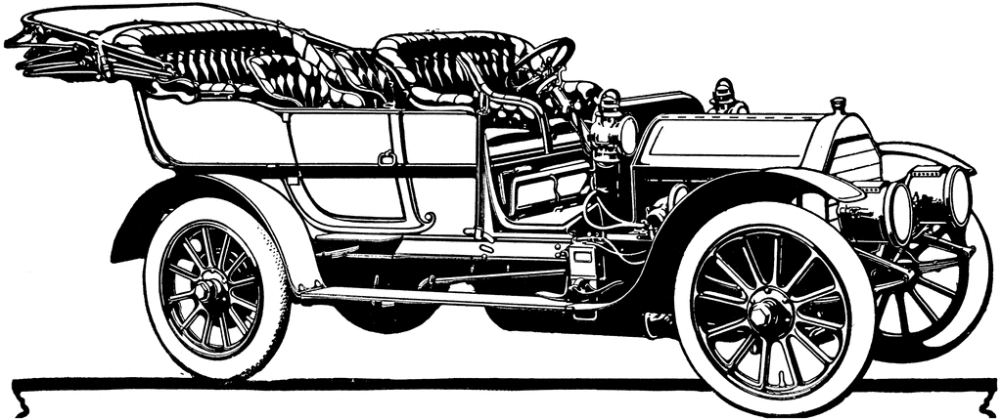

Women Changing Automotive History

Start

At the Forefront

Through many challenges, women have become leaders and innovators.